**Beechdale Health Centre**

**Edison Road,**

**Beechdale,**

**Walsall,**

**West Midlands,**

**WS2 7EZ**

**www.beechdalesurgery.nhs.uk**

**Tel: 01922 60 52 60**

**OPENING TIMES**

**Mon:** **8:30am - 6:30pm**

**Tue: 8:30am - 6:00pm**

**Wed: 8:30am - 1:00pm - Hub 1:00pm – 6:30pm**

**Thu: 8:30am - 6:30pm**

**Fri: 8:30am - 6:00pm**

**TELEPHONE NUMBERS**

**Appointments & Prescriptions**

01922 60 52 60

(To order Prescriptions contact the practice between 10:00am and 12:00pm)

**Enquiries and Results**

01922 60 52 60 - Please ring after 12:00pm

**Nearest Walk in Centre**

Saddlers Shopping Centre,

Bridgeman St,

Walsall

WS1 1YT

Phone: 01922 605730

**PALS Service**

Patient Advice and Liaison Service

01922 656956

**For Health Information go to:**

**www.patient.co.uk**

**NHS England**

NHS England. PO Box 16738. Redditch. B97 9PT.

Email to: england.contactus@nhs.net. Telephone: 0300 311 22 33.

**PRACTICE Team**

# Beechdale Surgery Team

**Accountable GP:** Dr Gian Singh (M) (MB.BS LMSSA)

**Non-Clinical Partner:** Amrit Singh

**Locum GP:** Dr Jaswinder Bal (F) (MBChB nMRCGP DRCOG DfSRH)

**Practice Nurse:** Mrs Maxine Clansey (F)

RGN (1984), Specialist Practitioner - General Practice Nursing (2013), Nurse Independent/Supplementary Prescriber (2013)

**Practice Manager:** Tracey Thomas

**Health Care Assistant:** Jeanette Bradley

**Reception Manager:** Debbie Ferguson

**Senior Receptionist:** Nicky Corbett

**Receptionists**: Sarah Williams

**Receptionists**: Emily Ferguson

**PRACTICE Boundary**

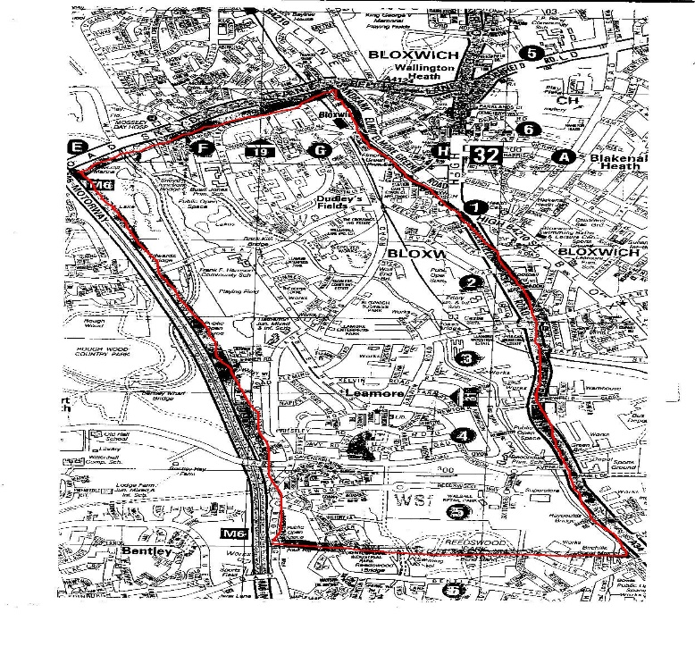

|  |
| --- |
| **Beechdale Health Centre**  PRACTICE LEAFLET  Information for  Patients |

The Freedom of Information Act gives you the right to request information held by a public sector organisation.

Unless there is a good reason, the organisation must provide the information within 20 working days.

**Dr Gian Singh**



**The Rights and Responsibilities of the Patient**

At all times you will be treated with courtesy and respect. We ask that you treat all staff with the same courtesy and respect. You will be given appropriate treatment and will be referred to the appropriate consultant when the GP deems necessary.

Reviewed 19/07/2023 V7

**HOW TO REGISTER AS A PATIENT**

Any persons within the Practice Area wishing to register with the practice should report to the reception desk. You will receive an appointment for a New Patient Medical. The Practice may refuse to register a patient. You will receive a refusal in writing. Following your registration, you will be required to have a new patient check to enable your registration to be fully complete. You will be offered an appointment with the Practice nurse or HCA

**DISABLED ACCESS**

Our surgery is accessible to patients using a wheelchair, automatic Front Door Access, parking spaces outside our practice reserved for patients displaying a disabled sticker. Disabled toilets are available.

**INTERPRETERS**

If English is not your primary language, an interpreter will be booked.

**OUR SERVICES**

Your practice provides, General Medical Services

Chronic Disease management, Screening Hypertension, Cancers, Mental health, hypothyroidism, Epilepsy, Stroke, Asthma, Diabetes, COPD. Child Health Surveillance. Family Planning, Cervical Cytology, ECG, Phlebotomy child Immunisations, Medication Reviews, Pill Check, Contraception advice, NHS Health Checks, Alcohol, Over 75 Health check.

**DATA PROTECTION**

All information held about patients is completely confidential. The Practice is registered under the Data Protection Act 1984. This Act protects data held on the computer system.

**Disclosure of patient information**

All patient information is protected under the data protection act 1998, A Caldicott guardian is assigned to the practice.

**HOME VISITS**

Home visit requests are for those who are unable to come to the Surgery because of serious illness and infirmity. Requests for home visits will be acknowledged if the patient is in need of medical assistance and is unable to attend surgery due to illness or disability. The doctor will decide whether a home visit is appropriate. Requests by 10:00am if possible. Whenever possible we prefer to see you at the Surgery; if you do not feel well enough to sit in the waiting room, we can make alternative arrangements.

**APPOINTMENTS**

All clinics are by appointment, and can be made in person or by telephone. We offer online booking of appointments, and we reserve appointments each day for patient access.

If you are unable to attend for your appointment, please let us know so that we can offer this to another patient.

You can book appointments in advance for Monday, Tuesday, Wednesday, and Thursdays. Friday’s appointments are bookable only on the day.

**PRESCRIPTIONS**

**Repeat Prescription Requests**

48 hours’ notice is required for any repeat prescription. Prescription requests may be made at reception, by post, by telephone or Online. Please ensure Name, Address, Telephone No and D.O.B. are entered on each request, along with the medication, strength and quantity required.

**TELEPHONE ADVICE**

The Doctor/Practice nurse is available to give telephone advice after morning surgery. Patients are advised to telephone reception before 11:00 am.

**OUT OF HOURS PLEASE RING – 111**

On Wednesday between 1pm and 6pm please ring OurNet on **01922 501999** thereafter NHS 111.

**Midwifery Services**

Care to women during pregnancy and childbirth; liaise between primary health care teams and hospital obstetric teams, in planning and implementing care.

**Health Visitor Service**

A Trained General Nurse concerned with health of the whole family, supporting also other vulnerable groups, e.g. carers and those with special needs. Antenatal, Postnatal and breast-feeding support. Child health development, nutrition, immunisations, advice on parental/behaviour management (0 – 16 years).

**How you can access your own Health Records**

If you want on-line Access to see, your health records you will need to make a written request to the Reception Manager. For further information, please ask at the reception desk.

**Patient preference of Practitioner**

A patient has a right to express a preference to receive services from a particular performer or class of performer either generally or in relation to any particular condition. Expressions of preference are to be made in writing to the Practice Manager.

**Suggestions and Complaints**

We aim to provide a high quality service at all times. We recognise that there may be occasions when our service falls short of what you may expect from us. Please feel free to discuss any concerns you may have with the Practice Manager. If you are dissatisfied with the service, we provide you have a right to leave our list and re-register with another practice. You do not need permission from our GP to change to another practice. Alternatively, you may write: Time2Talk team, Black Country ICB, Civic Centre, St Peters Square, Wolverhampton, WV1 1SH. Email: [bcicb.time2talk@nhs.net](mailto:bcicb.time2talk@nhs.net) or NHS England Address: PO Box 16738 Redditch B97 8PT. Email: england.contactus@nhs.net 0300 311 2233 or Patient Advice & Liaison Services (PALS) Manor Hospital, Tel: 01922 656463, Moat Road Walsall, WS2 9PS.

**How the practice uses personal information**

Dr Singh Provides posters and patient leaflets to explain why information is collected about you and the ways in which this information may be used.

**Aggression and Abuse**

This practice considers aggressive behaviour to be any personal, abusive and aggressive comments, cursing and/or swearing, physical contact and aggressive gestures.

No abuse of staff is acceptable. All abuse will be reported to the Practice Manager who will report to NHS England and the Police. If appropriate, the Practice Manager will send a formal letter to the patient. A copy will be kept in the patients electronic medical records. Any response to the letter will be recorded.

**Patients not seen within three years**

If you have not been seen at the surgery for three years (or one year for those over 75) you can request a check-up appointment.